SPRING SECURITY

Useful links: <https://docs.spring.io/spring-security/site/docs/4.2.3.RELEASE/reference/htmlsingle/>

Spring Security Model:

1. A separate framework is defined
2. Implemented using servlet filters in the background
3. Two methods of securing a web app:
   1. Declarative
   2. Programmatic

Servlet Filters:

1. Used to pre and post process web requests
2. Can route the web requests based on security logic

Overview:

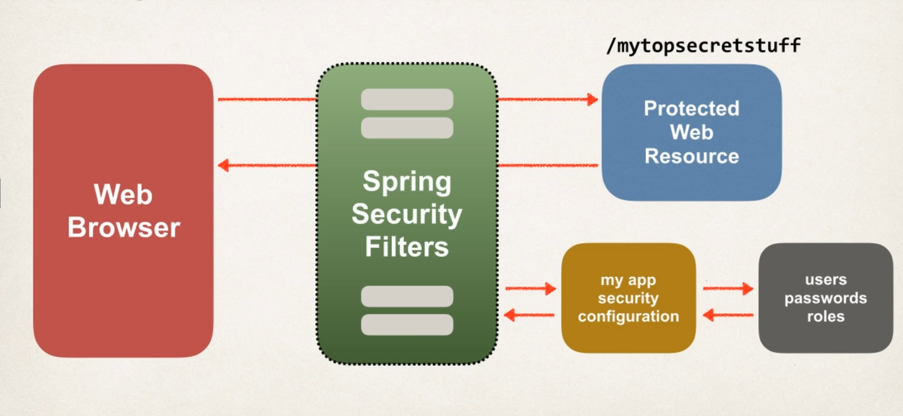

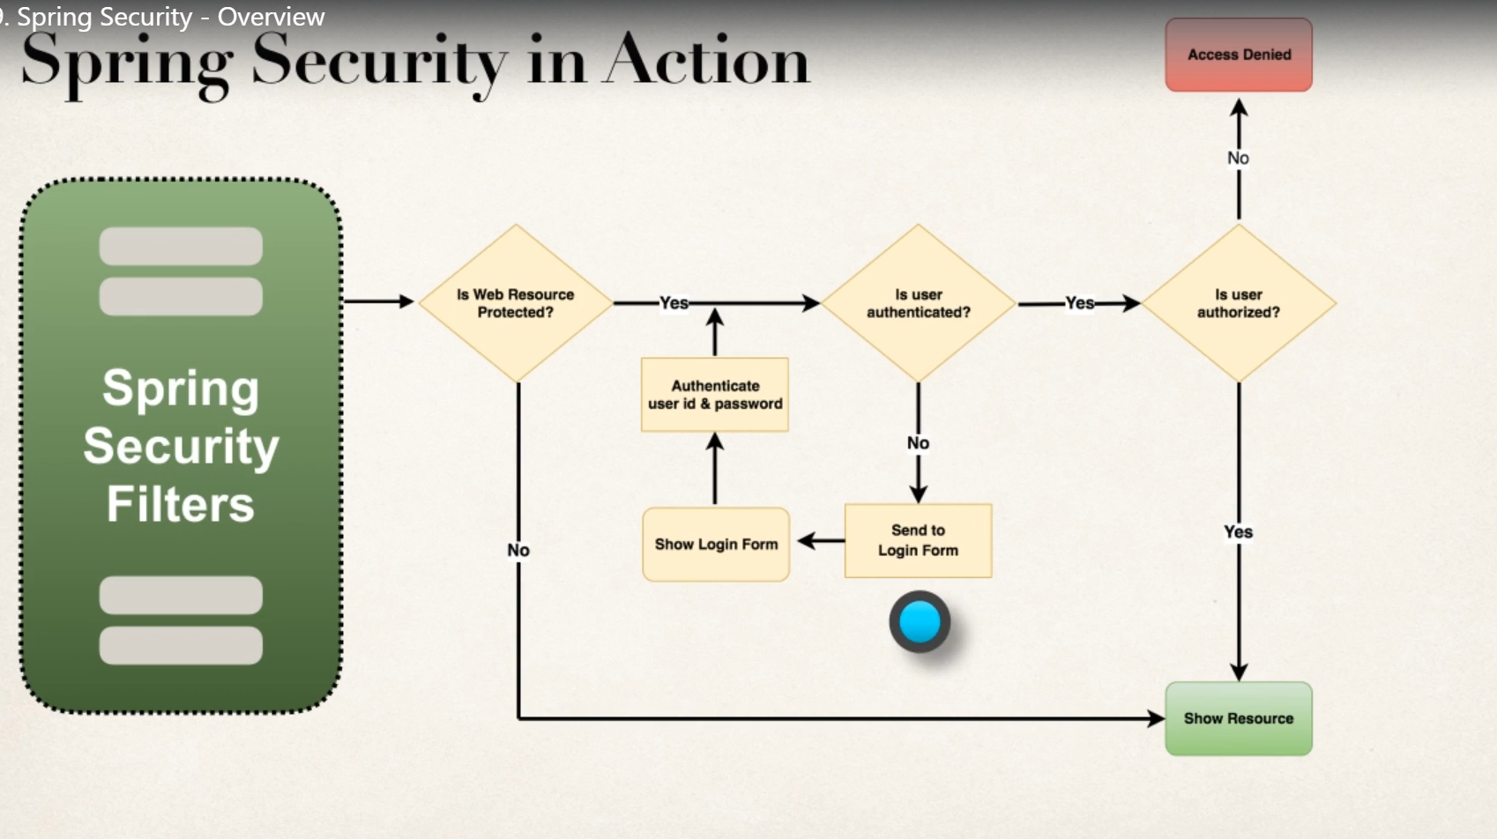

1. Authentication
2. Authorization

Declarative Security:

Provides separation of concern between application code and security code

Programmatic Security:

Spring Security provides API for custom application config

Provides greater customization for specific app requirements

Different Login Methods:

1. HTTP Based – Built in dialog from browser (used very rarely)
2. Login Form – given by spring (used only for quick start)
3. Custom Login Form

Spring Security Web App Initializer

1. Spring Security provides support for security initialization
2. Your security code is used to initialize the servlet container
3. Special class to register the **Spring Security Filters**
   1. AbstractSecurityWebApplicationInitializer class must be extended